**Sum-Meet**

Use Case Specification

Submitted to:

Asst. Prof. Ma. Rowena C. Solamo

Faculty Member

Department of Computer Science

College of Engineering

University of the Philippines, Diliman

Submitted by:

Batula, Bryce Spencer

Bayuga, Michael John

Yap, John Theodore

In partial fulfillment of academic requirements

for the course

CS 191 Software Engineering I

of the

1st Semester, AY 2015-2016

Unique Reference:

The documents are stored in https://github.com/trackertech568/CS191-Batula-Bayuga-Yap.

[File Reference in GitHub, preferably link.]

Document Purpose:

To show the flow of events of a use-case from its diagram.

Target Audience:

Meeting organizers.

Revision Control

*History Revision:*

| Revision Date | Person Responsible | Version  Number | Modification |
| --- | --- | --- | --- |
| 09/18/15 | Batula, Bryce  Bayuga, Michael  Yap, John Theodore | 1.0 | Initial Document; Version number should match the one found in the footer. |
|  |  |  |  |

*Use-Case Name*: 1.0 Add Meeting

*Description:* A meeting organizer may set up a meeting. Meeting is then saved into the records, and an invite is sent to attendees. At this point, confirmation or rejection is a “don’t care”.

*Preconditions:* NONE

*Flow of Events:*

| Scenario Name | Description |
| --- | --- |
| Scenario 1 (Basic Flow)  Meeting Organizer creates a new meeting. | 1. Meeting organizer creates a new meeting.  2. Event is saved into the records.  3. Attendees are notified of the event (for attendance use-cases, see Use case 2.0) |

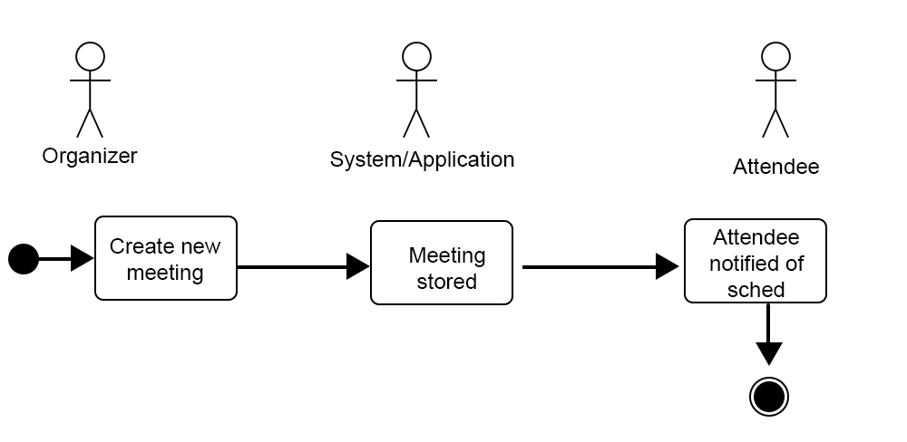

*Activity Diagram of the Flow of Events:*

*Postcondition:* NONE

*Relationships:* NONE

*Special Requirements:*

NONE

*Use-Case Name*: 1.1 Edit meeting

*Description:* A meeting organizer has access to an event he/she created. Organizer then has the ability to edit the details of his/her event. Attendees’ decisions are still considered “don’t care”s.

*Preconditions:* Event needs to be existing (Use Case 1.0).

*Flow of Events:*

| Scenario Name | Description |
| --- | --- |
| Scenario 1 (Basic Flow)  Meeting Organizer chooses to edit an event. | 1. Meeting organizer edits an event. 2. System saves all updates   3. Attendees are updated regarding the updated details.  4. If meeting organizer chooses to continue editing, repeat this step, else, move to Scenario 2. |
| Scenario 2  Meeting Organizer chooses to not edit an event. | 1. If there were any changes, changes are saved. 2. Else, end process. |

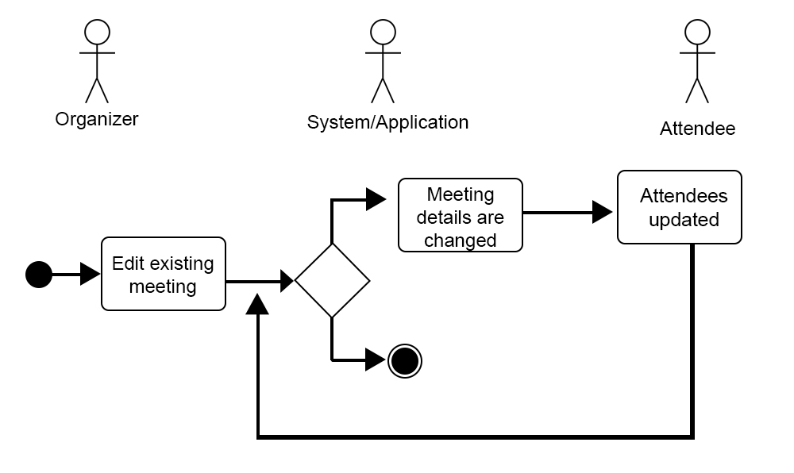

*Activity Diagram of the Flow of Events:*

*Postcondition:* NONE

*Relationships:* NONE

*Special Requirements:*

NONE

*Use-Case Name*: 1.2 Delete meeting

*Description:* Meeting organizers may delete or cancel an event. Attendees are notified of supposed event suspensions. Attendee participation is a “don’t care”.

*Preconditions:* Event must be existing (Use case 1.0)

*Flow of Events:*

| Scenario Name | Description |
| --- | --- |
| Scenario 1 (Basic Flow)  Meeting Organizer will delete an event. | 1. Meeting organizer chooses to delete an event.  2. Meeting is removed from the system.  3. System updates attendees regarding the suspension. |
| Scenario 2  Meeting Organizer chooses not to delete an event. | 1. End process |

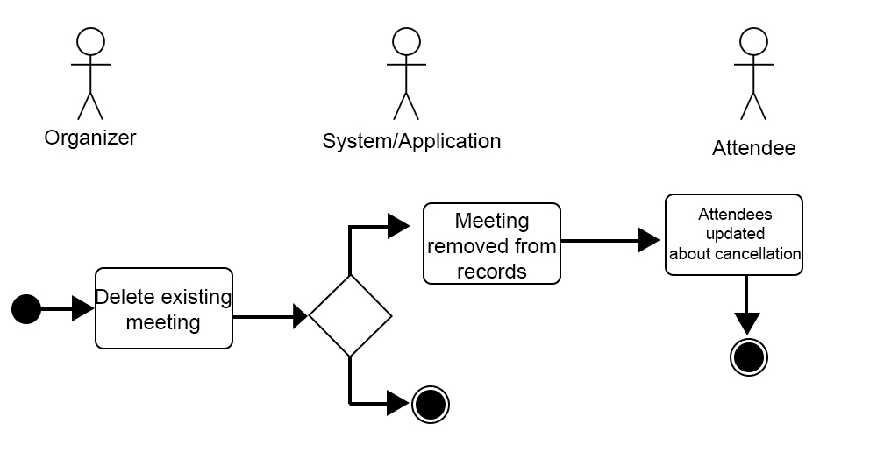

*Activity Diagram of the Flow of Events:*

*Postcondition:* NONE

*Relationships:* NONE

*Special Requirements:*

NONE